**Vendor Performance Analysis Report**

**Executive Summary**

* We analyzed the performance of 118 vendors across 7,707 products, focusing on profitability, efficiency, and inventory management.
* Key findings reveal that while certain vendors are highly profitable, others have potential pricing or overstock issues impacting business efficiency.

EXPLORARTORY DATA ANALYSIS INSIGHTS

**Summary Statistics**

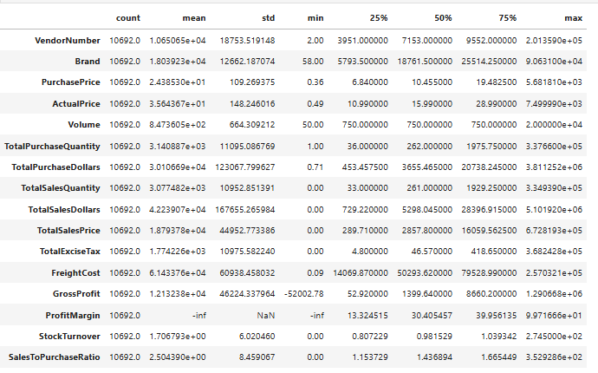

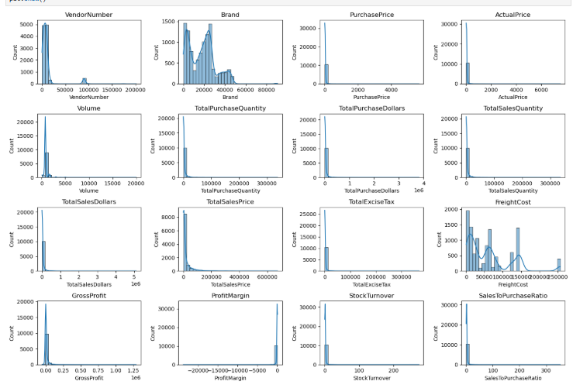

**Negative & Zero Values:**

**Gross Profit:** Minimum of -52002.78 indicating potential losses due to high costs or heavy discounts. This could be due to selling products at lower prices than their purchase costs.

**Profit Margin:** Has a minimum of -∞, which suggests instances where revenue is zero or even lower than the total costs, leading to extreme negative profit margins.

**Total Sales Quantity & Sales Dollars:** Some products show zero sales, indicating they were purchased but never sold. These may be slow-moving or obsolete stock, leading to inventory inefficiencies.

**Outliers Detected by High Standard Deviations:**

**Purchase & Actual Prices:** The maximum values (5681.81 & 7499.99) are significantly higher than the mean (24.39 & 35.64), indicating premium product offerings.

**Freight Cost:** Extreme variation from 0.09 to 257032.07 suggests logistics inefficiencies, bulk shipments, or erratic shipping costs across different products.

**Stock Turnover:** Ranges from 0 to 274.5, suggesting some products sell rapidly while others remain unsold for long periods. A value greater than 1 indicates the sales for a product exceed the purchased quantity due to older stock fulfilling orders.

**Data Filtering**

To enhance the reliability of the insights, we removed inconsistent data points where:

* Gross Profit ≤ 0 (to exclude transactions leading to losses).
* Profit Margin ≤ 0 (to ensure analysis focuses on profitable transactions).
* Total sales quantity = 0 (to eliminate inventory that was never sold).

**Correlation Insights**

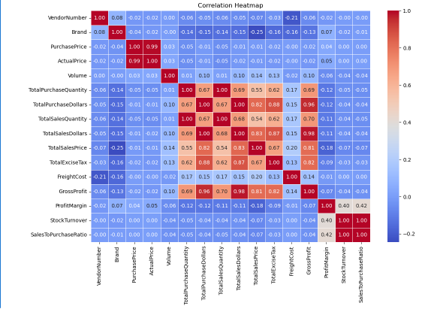

**Purchase Price Vs. Total Sales Dollars & Gross Profit:** Weak correlation (-0.012 and -0.016), indicating that price variations do not significantly impact sales revenue or profit.

**Total Purchase Quantity Vs. Total Sales Quantity:** Strong correlation (0.999), confirming efficient inventory turnover.

**Profit Margin Vs. Total Sales Price:** Negative correlation (-0.179), suggesting increasing sales prices may lead to reduced margins, possibly due to competitive pricing pressures.

**Stock Turnover** **Vs. Gross Profit & Profit Margin:** Weak negative correlation (-0.038 & -0.055), indicating that faster stock turnover does not necessarily equate to higher profitability.

**Research Questions & Key Findings**

**1.Brands for Promotional or Pricing Adjustments**

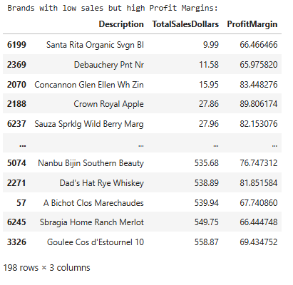

198 brands exhibit lower sales but higher profit margins, which could benefit from targeted marketing, promotions, or price optimizations to increase volume without compromising profitability.

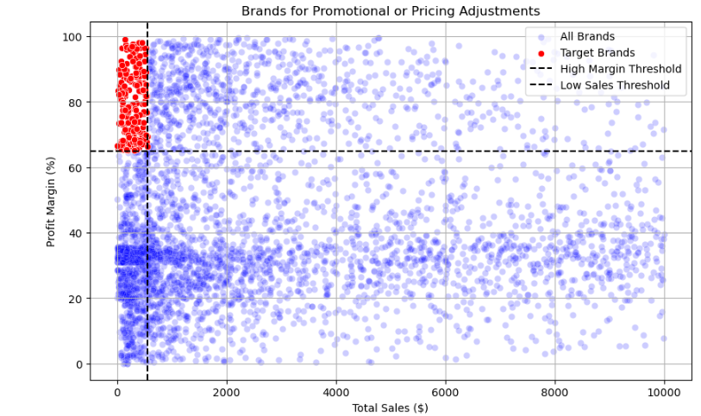

**2.Top Vendors by Sales & Purchase Contribution**

The top 10 vendors contribute 65.69% of total purchases, while the remaining vendors contribute only 34.31%. This over-reliance on a few vendors may introduce risks such as supply chain disruptions, indicating a need for diversification.

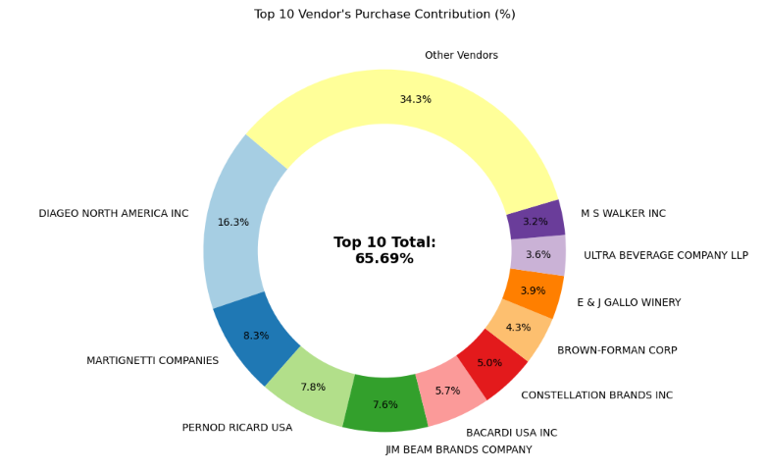

**3. Impact of Bulk Purchasing on Cost Savings**

Vendors buying in large quantities receive a 72% lower unit cost ($10.78 per unit vs. higher unit costs in smaller orders).

Bulk Pricing strategies encourage larger orders, increasing total sales while maintaining profitability.

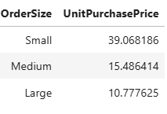

**4. Identifying Vendors with Low Inventory Turnover**

Total Unsold Inventory Capital: $2.71M

Slow-moving inventory storage costs, reduce cash flow efficiency, and affects overall profitability.

Identifying vendors with low inventory turnover enables better stock management, minimizing financial strain.

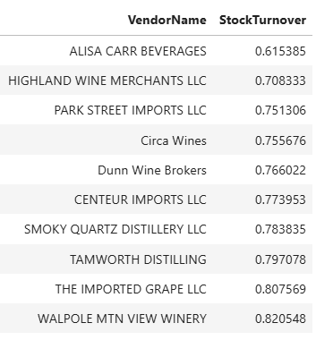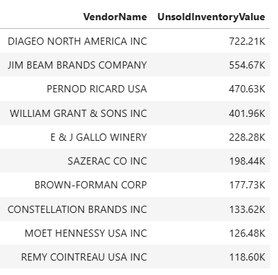

**5. Profit Margin Comparison: High Vs. Low-Performing Vendors**

Top Vendors’ Profit Margin (95% CI): (30.74%, 31.61%), Mean:31.17%

Low Vendors’ Profit Margin (95% CI): (40.48%, 42.62%), Mean: 41.55%

Low-performing vendors maintain higher margins but struggle with sales volumes, indicating potential pricing inefficiencies or market reach issues.

Actionable Insights:

* Top-Performing Vendors: Optimize profitability by adjusting pricing, reducing operational costs, or offering bundled promotions.
* Low-performing Vendors: improve marketing efforts, optimize pricing strategies, and enhance distribution networks.

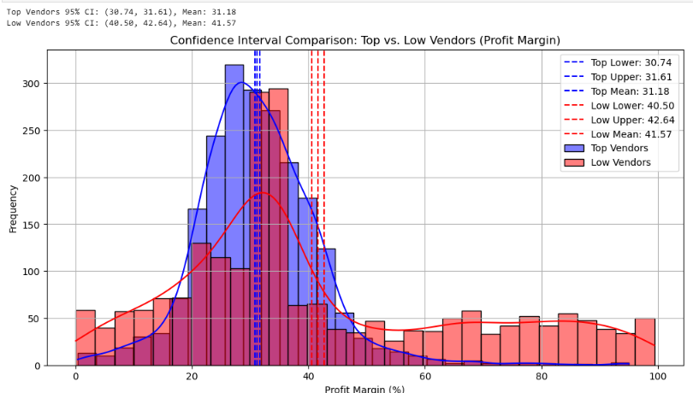

**6. Statistical Validation or Profit Margin Differences**

**Hypothesis Testing:**

H0 (Null Hypothesis): No significant difference in profit margins between top and low-performing vendors.

H1 (Alternative Hypothesis): A significant difference exists in profit margins between the two vendor groups.

**Result:** The null hypothesis is rejected, confirming that the two groups operate under distinctly different profitability models.

Implication: High-margin vendors may benefit from better pricing strategies, while top-selling vendors could focus on cost efficiency.

**Final Recommendations**

1. Re-evaluate pricing for low-sales, high-margin brands to boost sales volume without sacrificing profitability.
2. Diversify vendor partnerships to reduce dependency on a few suppliers and mitigate supply chain risks.
3. Leverage bulk purchasing advantages to maintain competitive pricing while optimizing inventory management.
4. Optimize slow-moving inventory by adjusting purchase quantities, launching clearance sales, or revising storage strategies.
5. Enhance marketing and distribution strategies for low-performing vendors to drive higher sales volumes without compromising profit margins.
6. By implementing these recommendations, the company can achieve sustainable profitability, mitigate risks, and enhance overall operational efficiency.